When WFIL-TV became Channel 6 in Philadelphia, Howard Jones was a hapless employee of Triangle Publications. A mediocre daytime radio personality of C’mon ‘n Dance on their AM station, management reassigned him from his radio gig to their nascent TV operation as a morning host for an audience of spoiled, toy-seduced, pre-kindergarten post-war children. Wearing heavy facial make-up which complemented an equally uncomfortable costume worn under blistering heat of early TV studio lighting, he assumed the character of Happy the Clown. He needed the work but hated the gig as his opinion of children aligned with those of W.C. Fields. When asked one time, “how do you like children, Mr. Fields”, the cankerous comedian simply replied “Boiled”.

The Happy the Clown show was sponsored by Miles Laboratories, makers of Bactine, an all-purpose “Family Antiseptic”. Its industrial strength ingredient, benzalkonium chloride, burned like hell, especially so, on freshly reddened tender skin, scraped raw by friction, especially so when kids slid down the untreated and ungreased magic slide on the TV show. Every kid that wailed in pain from their blood-reddened boo-boo was escorted off-stage and off-mike by Miss Beth, the equally hapless character sidekick, who would spray a generous amount of Bactine on the freshly exposed raw blister. Shrieks of pain filled the studio backstage. They could not be heard on the broadcast, but the primal screams worked liked therapy as each hyper- frenzied screech, alleviated deeply suppressed misopedic resentment for the host being relegated to this kiddie-TV purgatory. Bactine was the balm for a career dissatisfaction, which courtesy of the sponsor, offered the secret ingredient that put the happy, into the TV character of Happy the Clown.

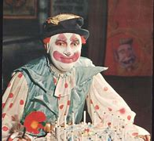

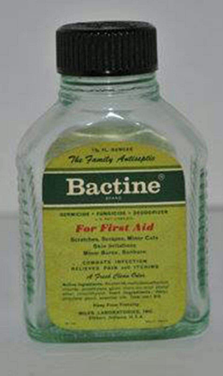

My ankles bear a gnarled scar from a kiddie slide, which allegedly led from Philadelphia to TV stardom.

