Ellen:

Though you might want to see what I discovered using a combination of family photos and ancestry to try to reconstruct the family story I never knew.

The photos came from Uncle Joe Weisberg’s (my paternal uncle) collection which I acquired from his son Mickey. I don’t remember seeing these photos in my grandmother’s photo album, so it was fascinating to see my Grandparents when they were kids, just starting here in the USA.

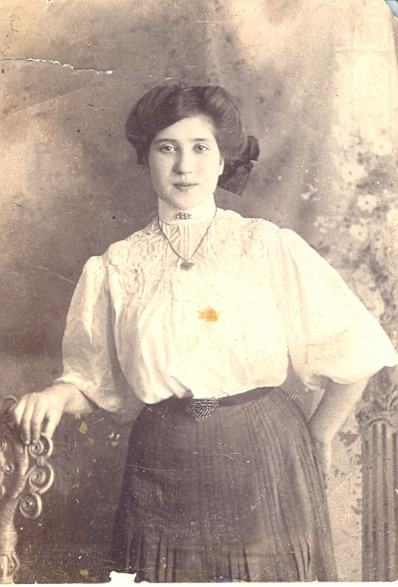
The is Fannie Liverant , my paternal Grandmother, taken on the occasion of her wedding engagement in 1910. She married Morris Weisberg in 1911. According to family stories, she was 15 or maybe 16 at that time; although, in actuality she may have been only 14. I found their marriage license application in my grandfather’s papers. It’s a copy from microfilm and it appears to have been altered.

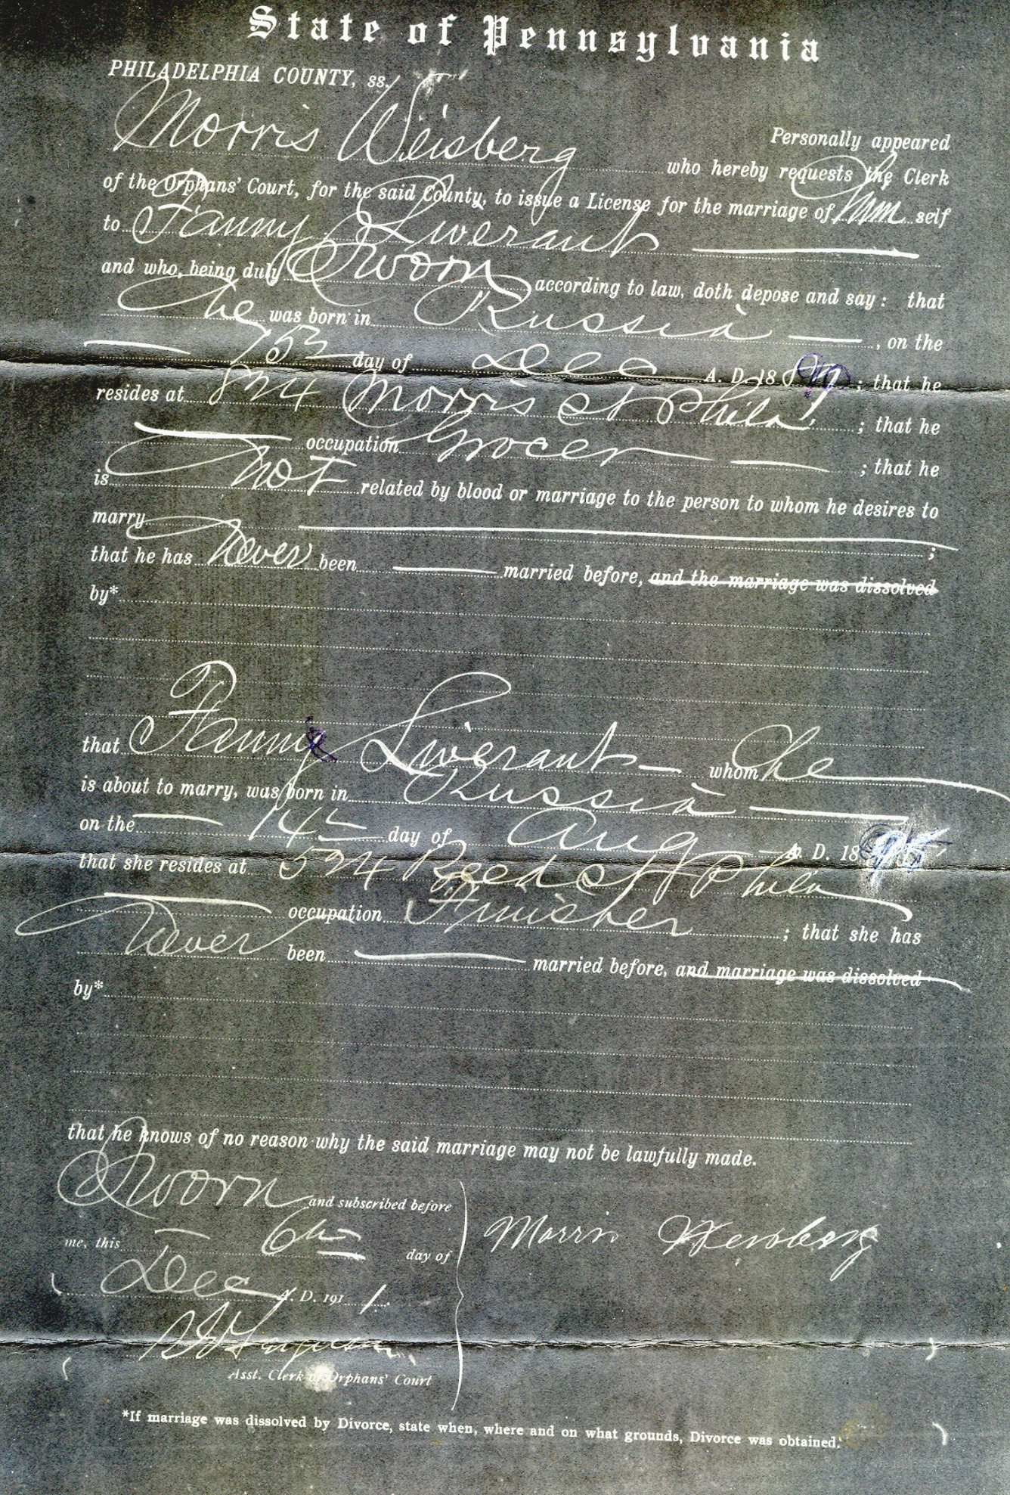

At about the same time as her engagement, a picture was taken of my grandmother along with her first cousin Pauline Novor. In the picture below, Pauline is on the left; Fannie on the right. My uncle, noted a ? in his photo album, indicating he couldn’t identify the woman seated in between them. It’s been a mystery I’ve wanted to solve ever since I first saw this picture. Today, drilling into Ancestry and looking at the census records from 1910, I figured it out. the other woman was Pauline’s sister-in-law, Ruchel (Americanized to Ray). Ruchel was related to my grandmother through marriage to Sam Novor, Pauline’s brother. According to the 1910 census, my grandmother was living in the same house with Sam and Ruchel, their two young girls, Sam’s Father, Benjamin Novor, and Sam’s Mother, Miyashi Novor (Americanized to Mary).

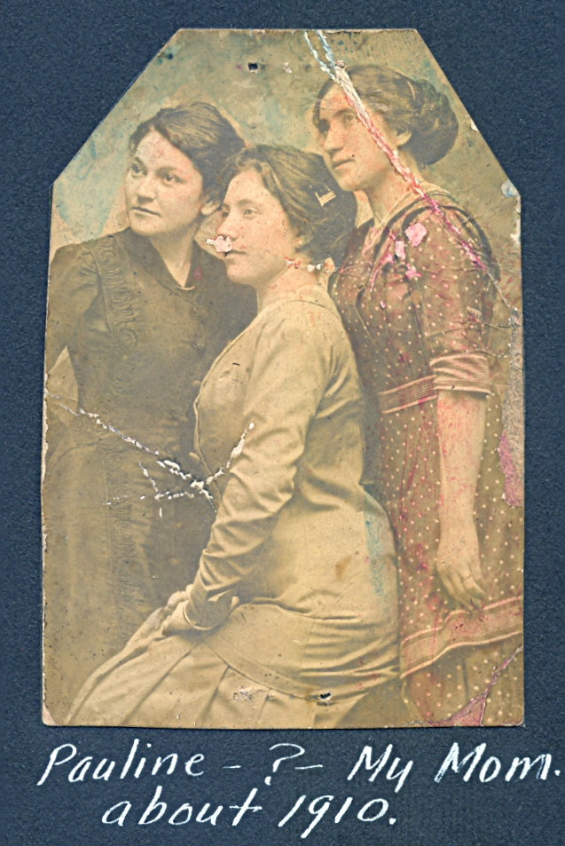

I found a photo of Miyashi, taken later in life which helped pull the rest of the story together. The Novors lived at 524 Reed Street in South Philadelphia; The Weisbergs at 908 Tasker.

I believe Benjamin Novor’s wife, Miyashi may have been the one to arrange the marriage of Fannie to Morris Weisberg, conspiring with Israel Weisberg’s wife, Itka (Americanized to Yetta) for the shiddach.

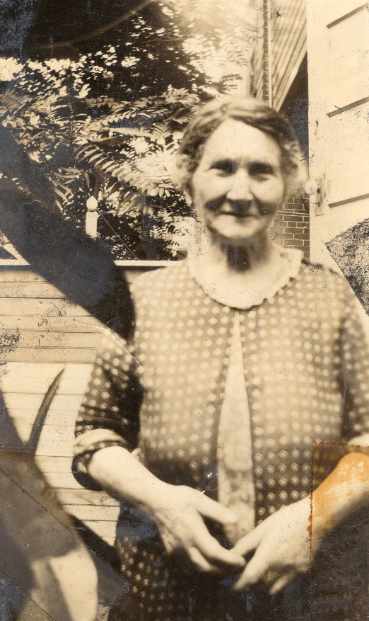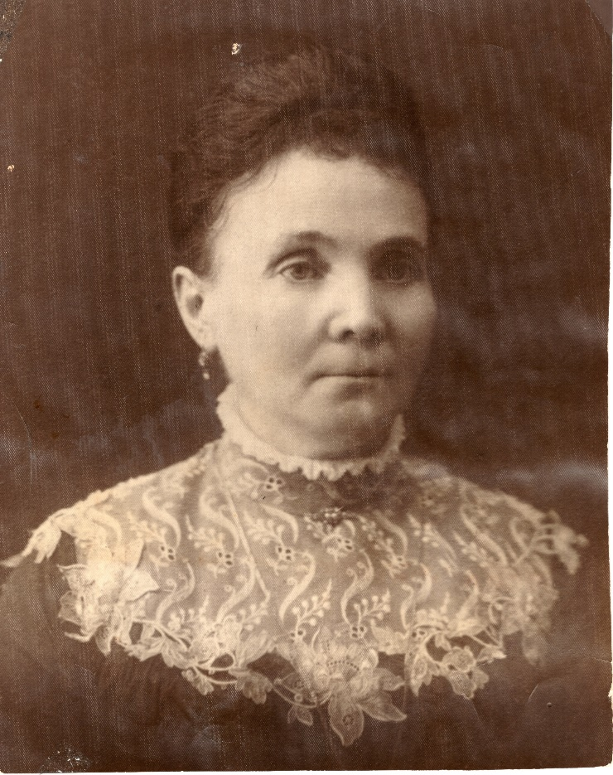
Miyashi Novor Itka Weisberg

Theirs was a marriage which was neither easy nor pretty, but Fannie and Morris lasted a lifetime. They never told me exactly how they met, but I think their story is one of kids being fixed up by their parents and having to depend on each other to make it in America despite all the odds. They explain Maxie’s keen ability to organize things since Fannie and Morris ran a small mom-and-pop grocery and kept a hawk-like watch on inventory in the store.

